Name: Kainaat Rafiq Hussain Makhani
Registration #: 2012296
Semester and Section: 7A
LAB 5

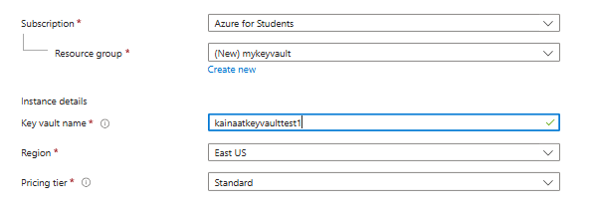

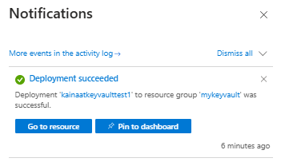

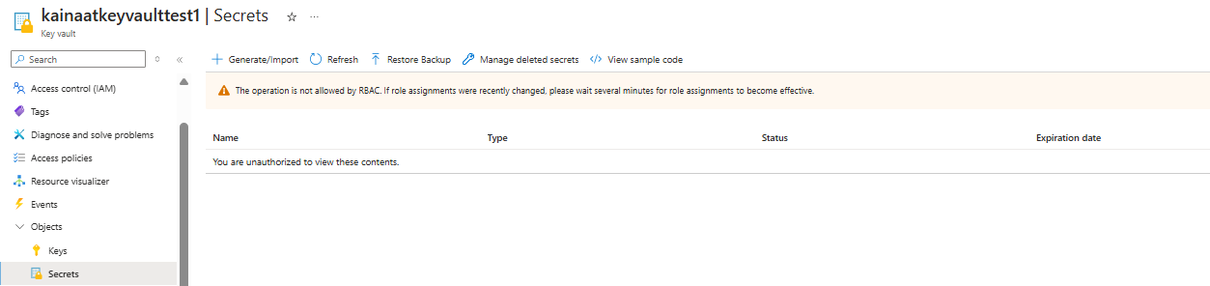

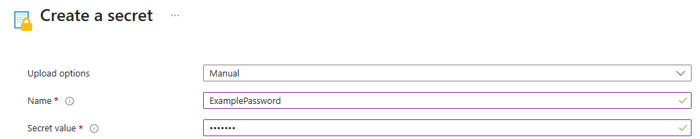

Description:
In this lab, we created and configured a Key Vault named kinaatkeyvaulttest to securely manage secrets. We used Azure IAM to assign roles like "Key Vault Secrets User" and verified access permissions. Access policies were reviewed and updated to allow secret management. After role assignment, we checked the secrets panel to confirm access. The lab helped understand how Azure handles role-based access and security for sensitive data.

